Title (14 pt)
The title should be no more than 12 words, clear, concise, informative.
Jargon and abbreviation should be avoided.
Title should be written in two languages: Indonesia and English

Abstract
Abstract should be independent; therefore, the author should not use citation in this part. Abstract should give concise explanation to the readers on the problems, aims, methods and findings as discussed in the manuscript. Based on this information, the readers are expected to understand the content and contribution of the manuscript. Abstract should be written in single paragraph and no more than 200 words. Abstract should be written in bahasa Indonesia and English.

Key words: Key words describe concepts that are discussed in the manuscript. Therefore, words in the title are not necessarily suitable and can be used as key words. Key words are generally used to make the process of searching and index easier. Key words contain 3-6 words.

Introduction
This part should describe background in general, literature review as foundation to confirm the novelty of the manuscript, the statement of the author on position on academic discourse, research questions or hypothesis that will be discussed in the manuscript. The written of literature as report of the research should be avoided. The literature should elaborate the previous studies and research. Therefore, the author can describe his/her position in the academic literature more clearly. The author should also elaborate the method that has been used to collect and analyze data. The method should give the details to make the readers easier to examine the suitability of the method, reliability, and validity of findings. The aims of the manuscript should be written at the end of introduction.

Several sub-titles illustrating main issues on the article
This part consists of several sub-sections. In this part, the authors describe the result of their empirical research or literature review (if the manuscript based on literature review). In addition, the finding should be linked with the discussion based on literature review used in the manuscript. This part should answer all the research questions had given in the previous section.

Closing
Conclusion should consist of summary and abstract of the whole manuscript. The summary should highlight the answers to research questions or hypothesis that given by author in the beginning of the manuscript. Therefore, this part should not repeat the findings and discussion. This part should deliver the final synthesis of the findings as expected in the aims of the manuscript. In addition, this part shows the contribution of the author on theoretical and practical aspects. The author can deliver the problems that can be used in the further research.

References
All the citation in the article should be listed in references section. The article should use new academic sources (70 percent of sources should be cited from article, book chapter and book which is publish in last 10 years). In addition, 30 percent references should come from other sources such as thesis, research report, news, and relevant other publication.

Books
Tirtosudarmo, R. (2015). On the Politics of Migration: Indonesia and Beyond. Jakarta: LIPI Press.

Book Chapter
Adhuri, D.A. (2009). Social identity and access to natural resources: Ethnicity and regionalism from a maritime perspective. In M. Sakai, G. Banks, & J.H. Walker (Eds.), The Politics of the Periphery in Indonesia: Social and Geographical Perspectives (hlm. 134-152). Singapore: NUS Press.
Thung, J.L. (2017). Agama dan identitas orang Tionghoa di Indonesia. Dalam R. Madinier (Ed), Revolusi Tak Kunjung Selesai: Potret Indonesia Masa Kini (hlm. 347-365). Jakarta: KPG & LÍrasec.

Journal Article
Santoso, W.M. (2010). Identitas, politik tubuh perempuan dan media televisi. Jurnal Kependudukan Indonesia, 5(1), 75-90.

Article with DOI
Burhani, A.N. (2014). Treating minorities with fatwas: A study of the Ahmadiyya community in Indonesia. Contemporary Islam, 8(3), 285-301. doi: 10.1007/s11562-013-0278-3.
Humaedi, M.A. (2013). Budaya Hibrida Masyarakat Cirebon. Humaniora, 25 (3), 281-295. doi: 10.22146/jh.v25i3.3540.

Article from Internet/Website
Hadi, A. & Tirtosudarmo, R. (2016). Migration, Ethnicity and Local Politics: The Case of Jakarta, Indonesia. Populasi, 24(2), 23-36. Retrieved from https://jurnal.ugm.ac.id/populasi/article/view/27228/16730.

Article from Newspaper
Haris, S. (2017, 10 Mei). Merombak kabinet. Kompas, hlm. 6.

Newspaper Article on Website
Mulya, T. W. (2016, 18 Agustus). Defining Indonesian-ness: Power, nationalism and identity politics. The Jakarta Post. Retrieved from http://www.thejakartapost.com/academia/2016/08/18/defining-indonesian-ness-power-nationalism-and-identity-politics.html

Website
Akmaliah, W. (2018, 6 Januari). Menyelami kompleksitas hubungan orang tua dan kids zaman now. 22 Januari 2018, Retrieved from https://geotimes.co.id/kolom/film/ menyelami-kompleksitas- hubungan-orangtua-dan-kids-zaman-now/.

Website Document
Badan Pusat Statistik. (2017). Jakarta dalam Angka 2016. Retrieved from https://jakarta.bps.go.id/backend/pdf_publikasi/Jakarta-Dalam-Angka-2016.pdf.

Translation Book
Lewis, O. (1988). Kisah Lima Keluarga: Telaah-telaah Kasus Orang Meksiko dalam Kebudayaan Kemiskinan. (Rochmulyati Hamzah, Terjemahan). Jakarta: Yayasan Obor Indonesia.

Example of Table, Figure, and chart

Table 1./Chart 1/Graphic 1.
Title (Bold)

Source: from primary data (italic)

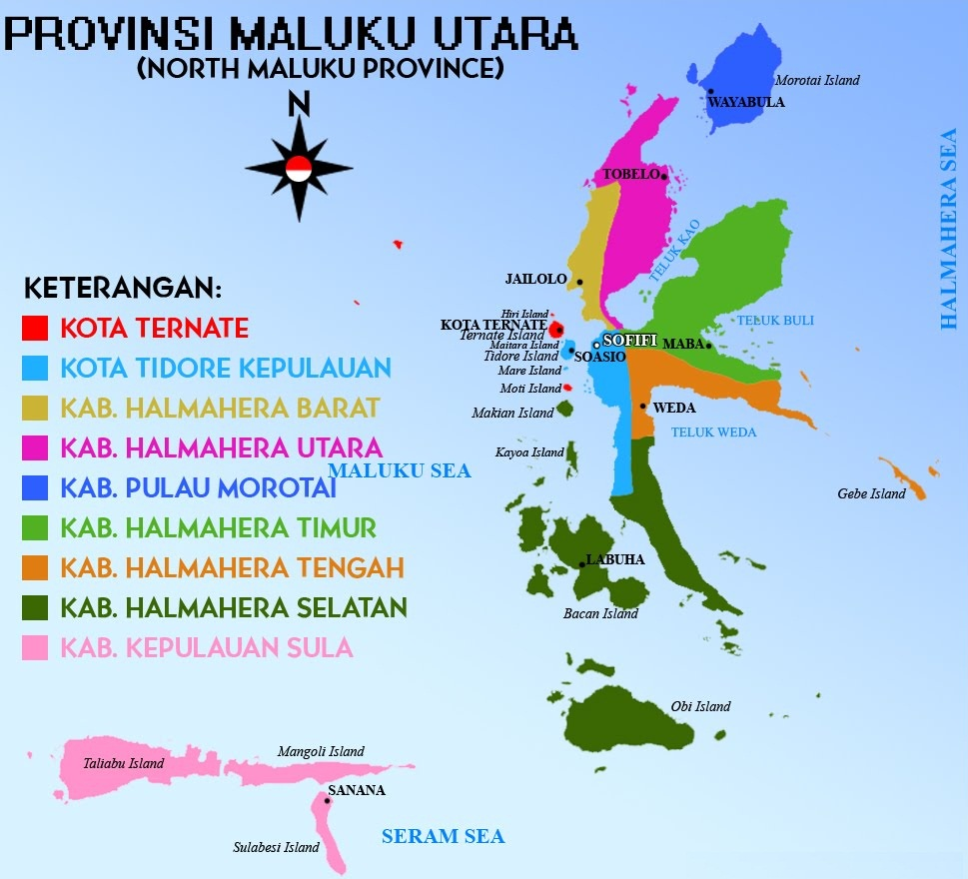
Source: from primary data (italic)

Figure 1. North Maluku Province

